Secondary Attraction Implementation in the Showcase Business Model

The Showcase with IMAX is a stand-alone Family Entertainment Center situated on a hill overlooking Lake Cunningham. As advantageous as that may be, management still had to consider all the nuances of the location. In doing so, the business model has been modified for a more robust product offering.
The Showcase Business Model:
- A Cineplex with 9 screens
- Expanded concessions with ice-cream and coffee
- Full serve restaurant with veranda
- Feature Attractions: IMAX, 4DX, VIP theater, VIP lounge
- Secondary Attractions: Full Arcade, Party Rooms, Kids Indoor Playground
To fully maximize the potential of this site, the Showcase with IMAX must become a destination not a location.
What’s the difference?
When tourists think of Las Vegas they think of gambling and adult fun. When they think about the Bahamas, tourist don’t think about its physical location. Thoughts of relaxing on beach flood their minds.
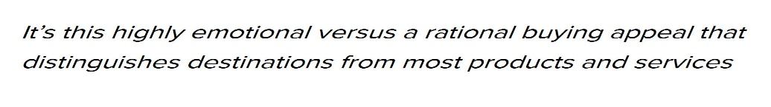

For a Destination;
Hence it’s the emotions and feelings of the consumer that turns locations into destinations, thereby driving consumer spending and loyalty to that destination. The Showcase must capture the imagination of its patrons from its commencement. To accomplish this goal the task must be approach in two stages:
- Structurally
- Philosophically
I. Structural Approach to Becoming a Destination

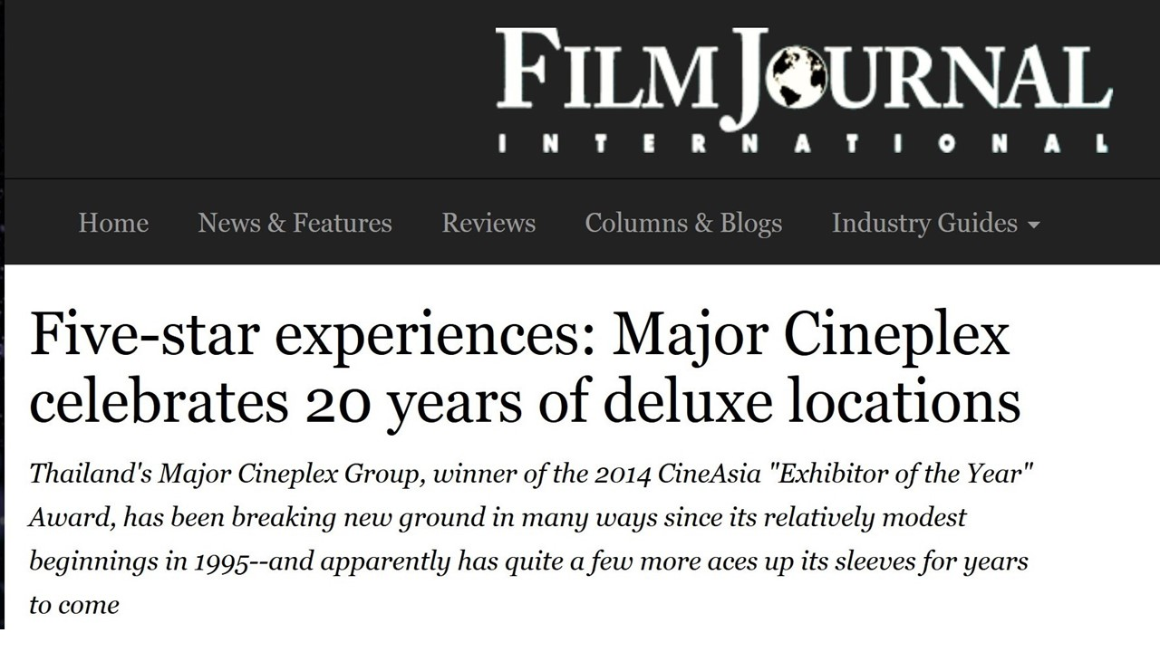
The first step in altering the prevailing ethos of Bahamian movie-goers was obtaining the right Design Architect. The selection of the award winning Smith Obayawat and the Office of Bangkok Architects provided a crucial knowledge base. No one in the western hemisphere had designed more facilities with IMAX and 4DX. Being the architect of record for Major Cineplex, recognized as one of the best cinemas on the planet, speaks volumes.
Localization of Smith Obayawat’s design was predicated on the Atavus Group’s research in the Bahamian marketplace. As discussed previously in the case study concerning Mario’s bowling, improper placement of key business model components can lead to:
- Complete failure of business components
- Under development of the business model
- Financial woes because the product offering is not strong enough to maintain long term viability
Understanding the layout of the Showcase with IMAX is fundamental in deciphering the Facility Segmentation Strategy the same has employed. Great thought has been taken to maximize the square footage of the facility while exuding class with functionality. Fundamental to this endeavor is mastering visitor circulation patterns.
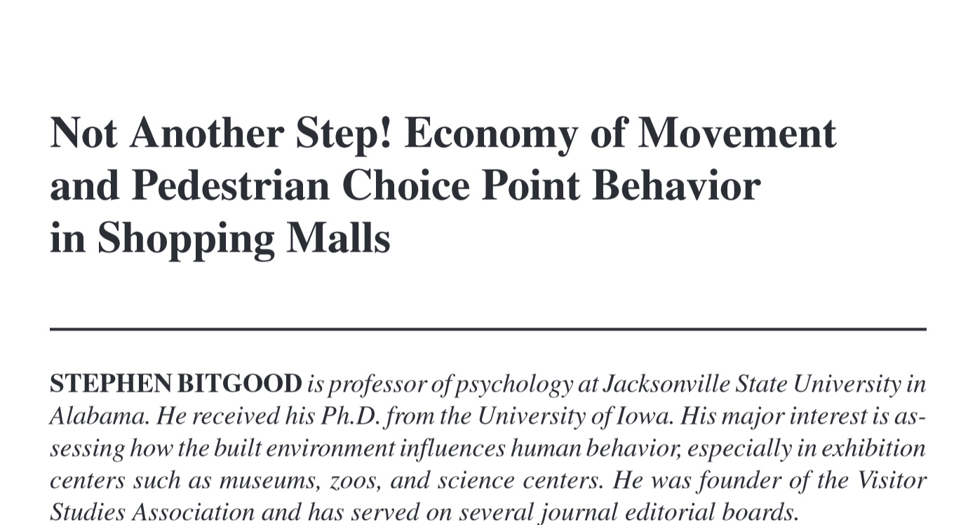
An important study was published that influenced customer flow when entering high traffic facilities specifically ones with cinemas:

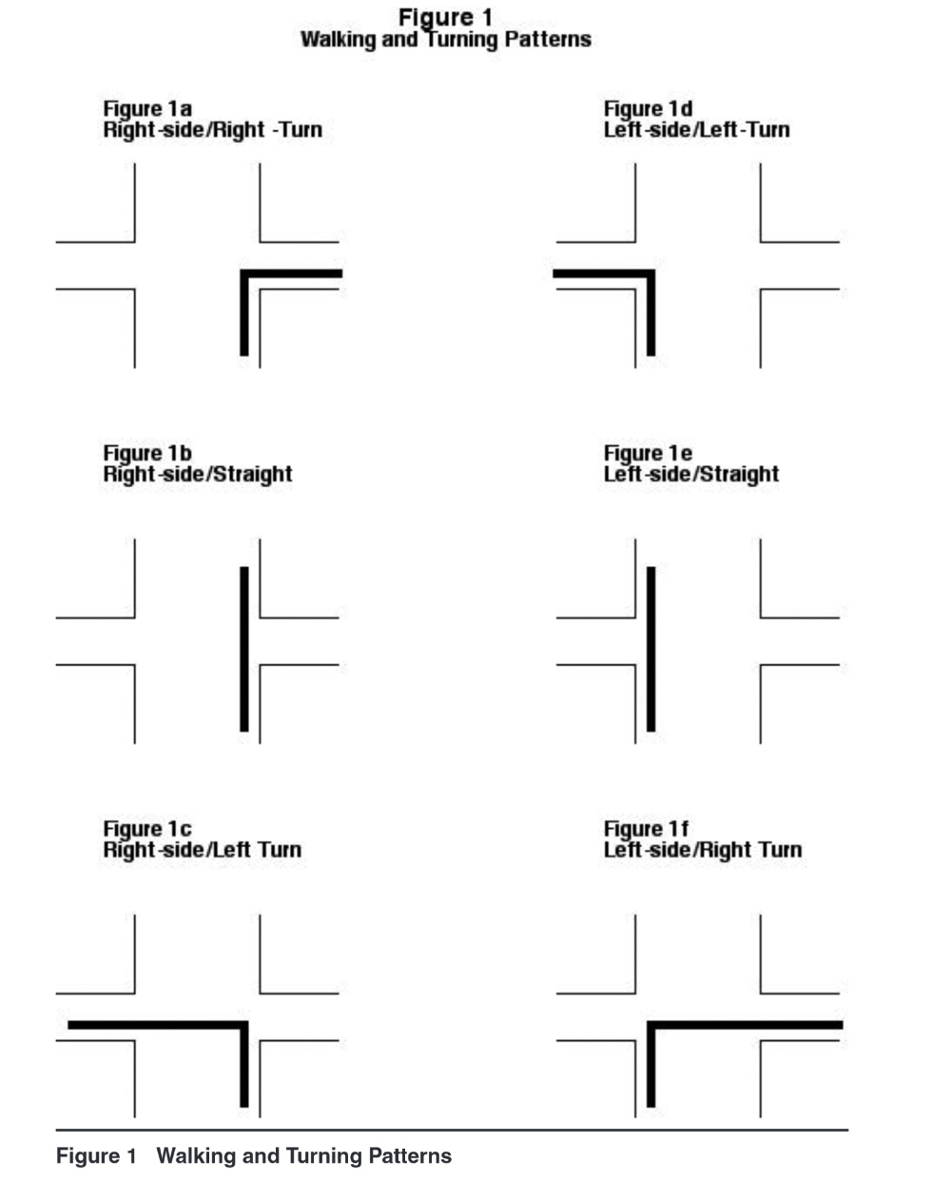
Dr. Bitgood’s finding display tendencies of patrons as they first walk in from a main entrance of a facility:
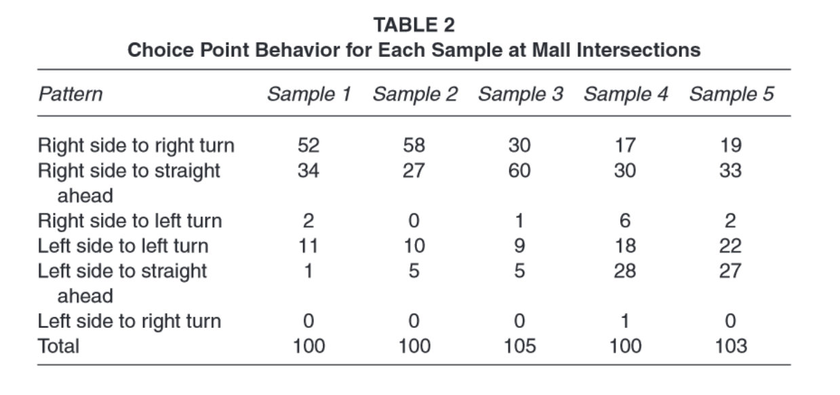
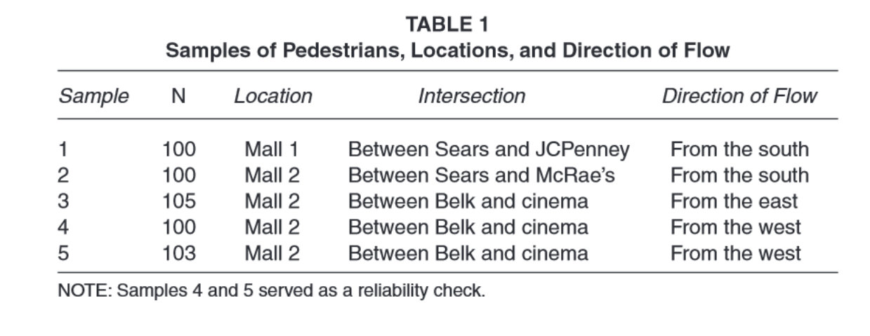

Hypothesis:
Patrons were more likely to walk straight or turn on the side they currently occupy before crossing over into opposing traffic flow. Dr. Bitgood postulated that when designing retail spaces or high traffic areas elimination of customer confusion is key. As consumers walk through the facility’s main entrance:
- Placing access points (stairs and paths) to non-anchor attractions should optimally be in front of the patron (not to the left or right of the traffic flow). This increases foot traffic in those areas.
- Anchor attractions can be placed across the traffic flow direction because patrons will go against instinct to obtain what they consciously desire.
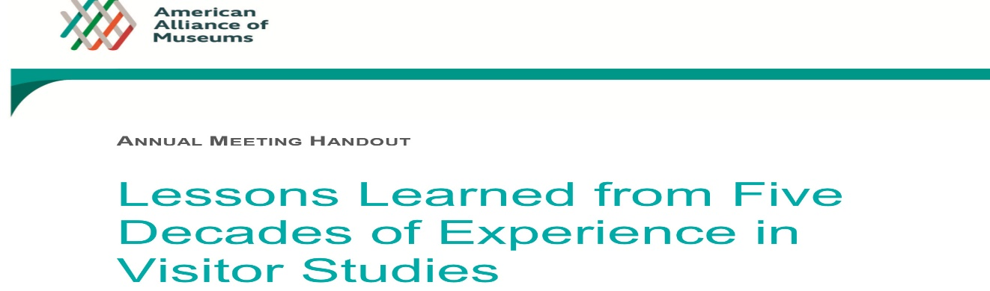
Note: These finding were cohobated by institutions that specialize in IMAX screens:
These finding are reflected in the Showcase with IMAX lobby layout. Access to secondary attractions are placed directly in from of the patron as they enter the facility:
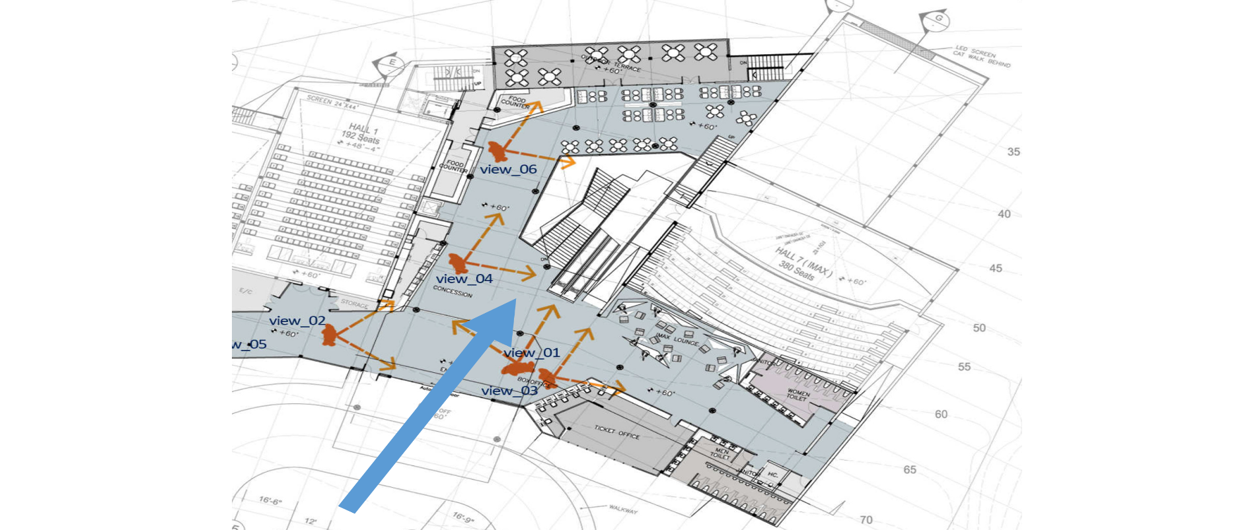
Stairs to Bottom Level featuring Kids Area
Escalator to Top Level featuring Restaurant and VIP Area

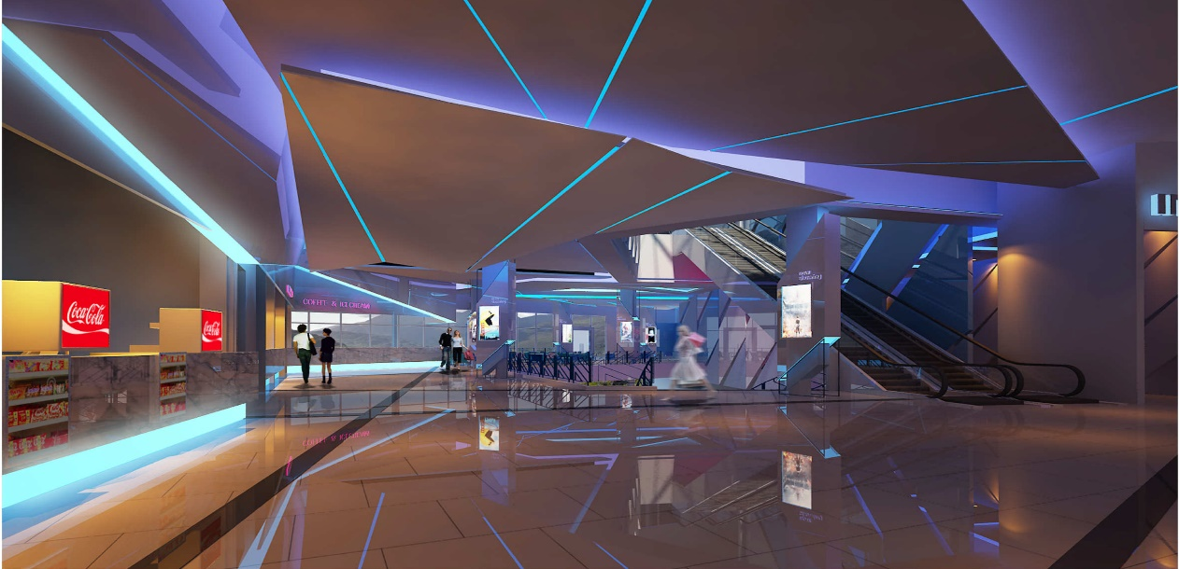
Showcase Lobby Conceptual Drawing

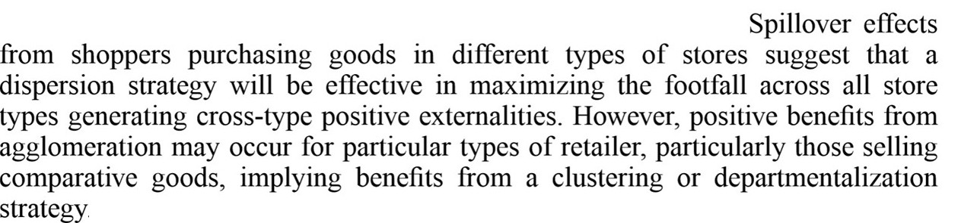
Building on this concept is the understanding that each entity in the Showcase with IMAX should be treated like its own retail space. From the restaurant to the arcade, placement of these spaces is crucial for synergy and the overall viability of the project. This concept is explained in the following study:
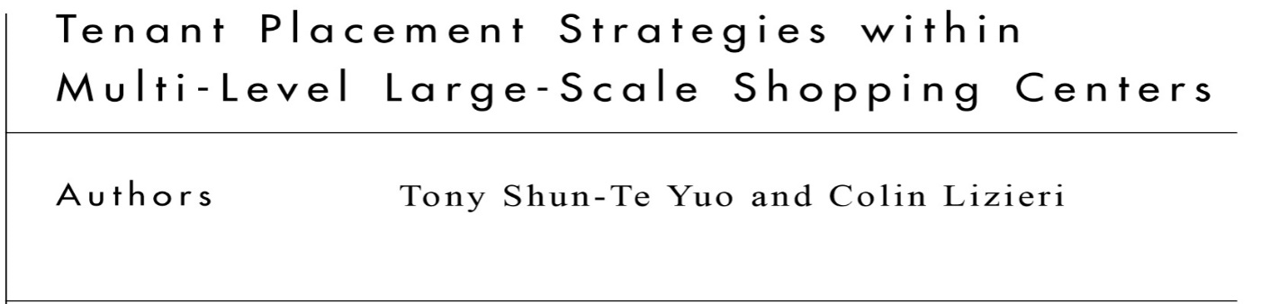
Conclusion:
Separation of related activities / products into clusters or floors will maximizes foot traffic while eliminating customer confusion. Why? Customers can make informed decisions while getting exactly what they want in the location they expect the product/activity to be. This is why the Showcase with IMAX has dedicated floors with specific motifs and target audiences.
- The Lower Level: The Arcade/Soft-play for the young and young at heart (Secondary Attraction)
- Main Entry Level: The General Public at a movie ( Primary Attraction)
- The Upper Level: The Upscale Clientele at the VIP lounge and Restaurant ( Secondary Attraction)
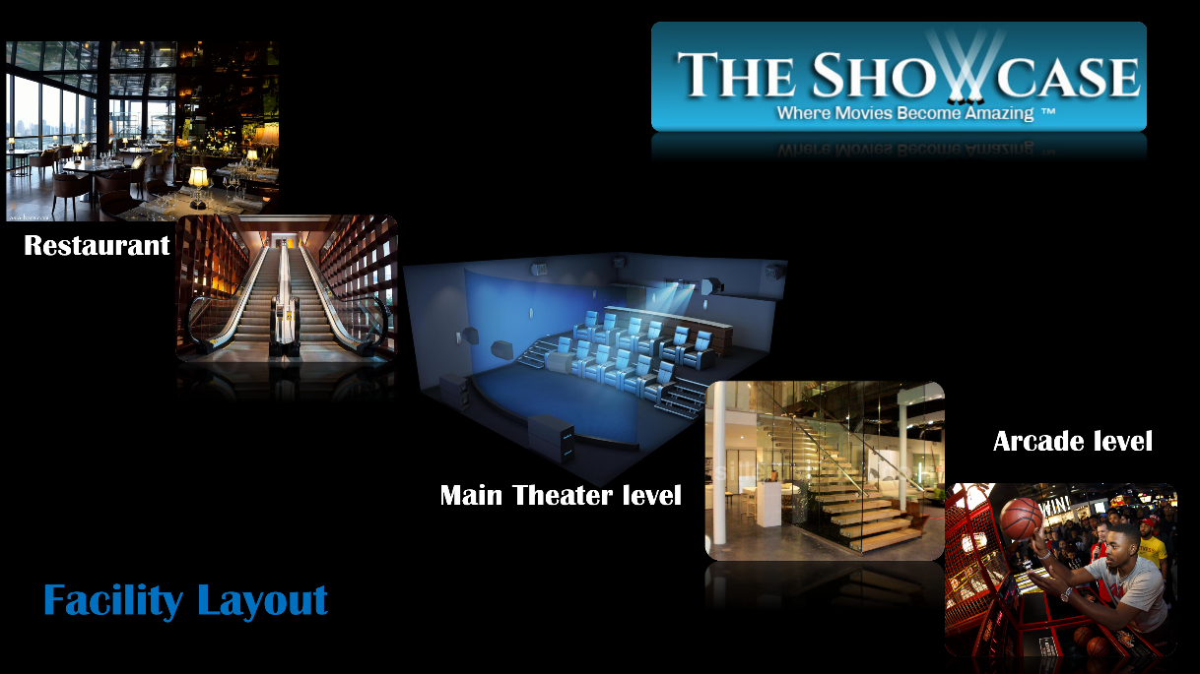
This allows each floor to become a DESTINATION within itself, for each target group.

II. Philosophical Approach to Becoming a Destination

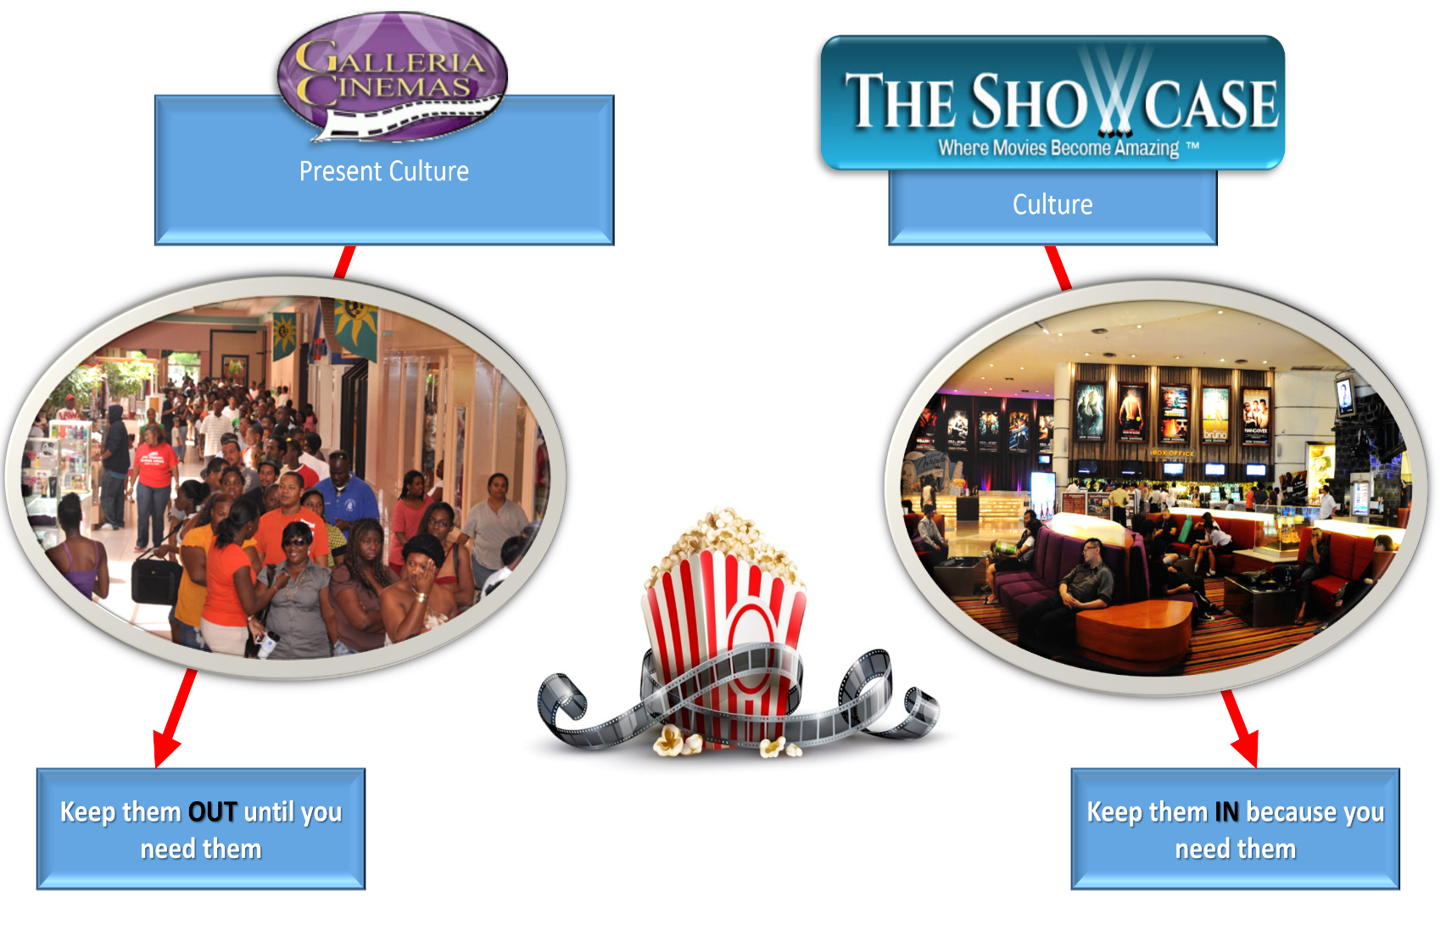
Change the Bahamian Theater Culture experience, thereby shifting present mindset of the Consumer.

With the structural component already in place, this philosophical change can now be properly implemented. No longer will patrons be asked to wait outside until movies are close to commencing. Access will be granted to all non- ticket requiring areas. From the very inception of the relationship with the Bahamian public, customers are treated differently. Customers are invited to stay and enjoy the facility. Free Wi-Fi is provided and comfortable seating are just the beginning of amenities. All of this is in the pursuit of the heart of the consumer.
Open Lobby of the Showcase with IMAX
Customers have free access
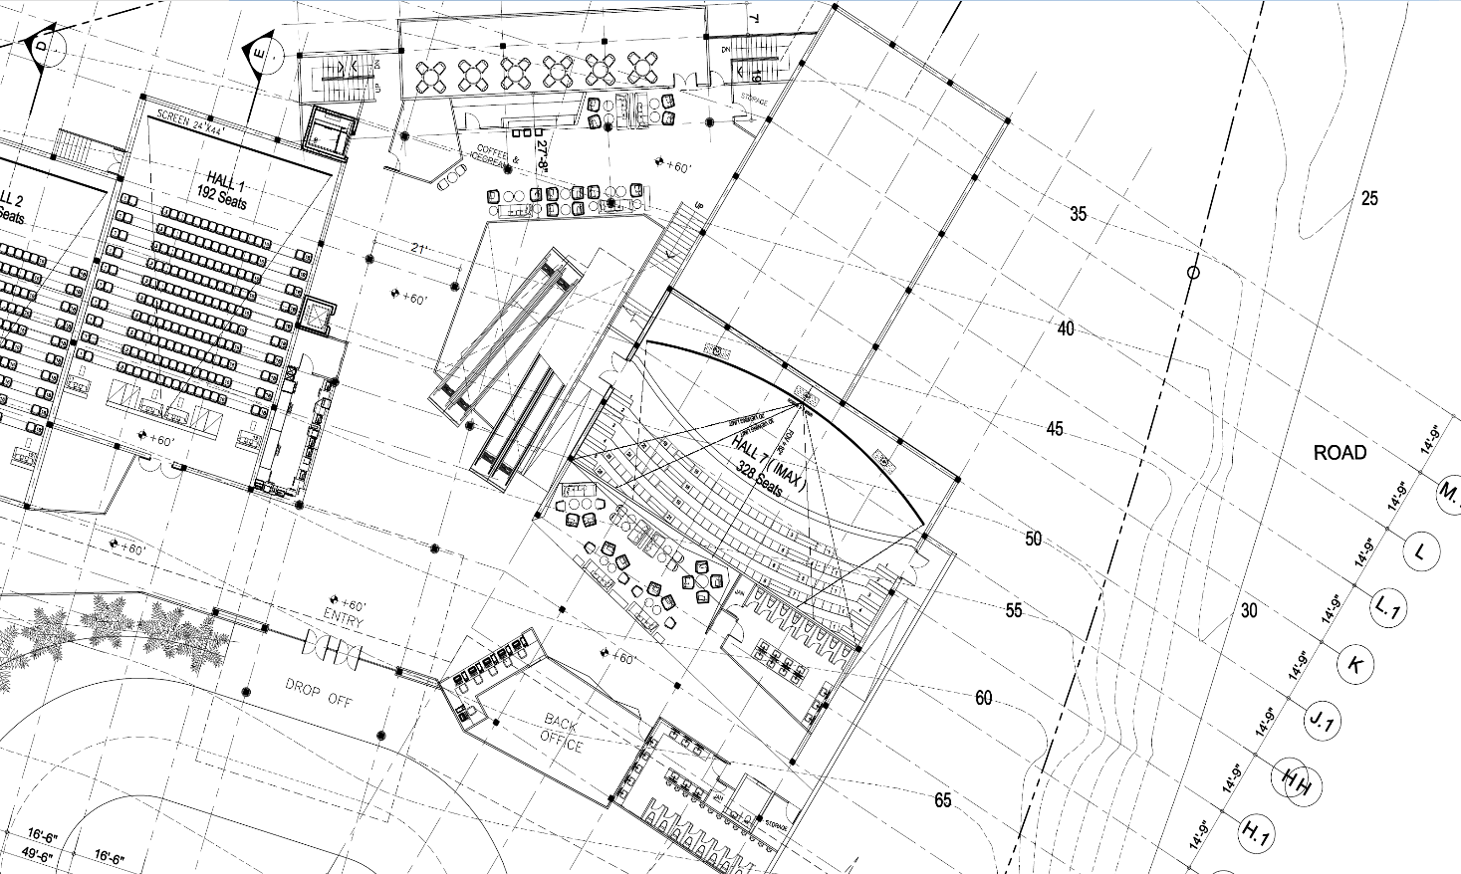

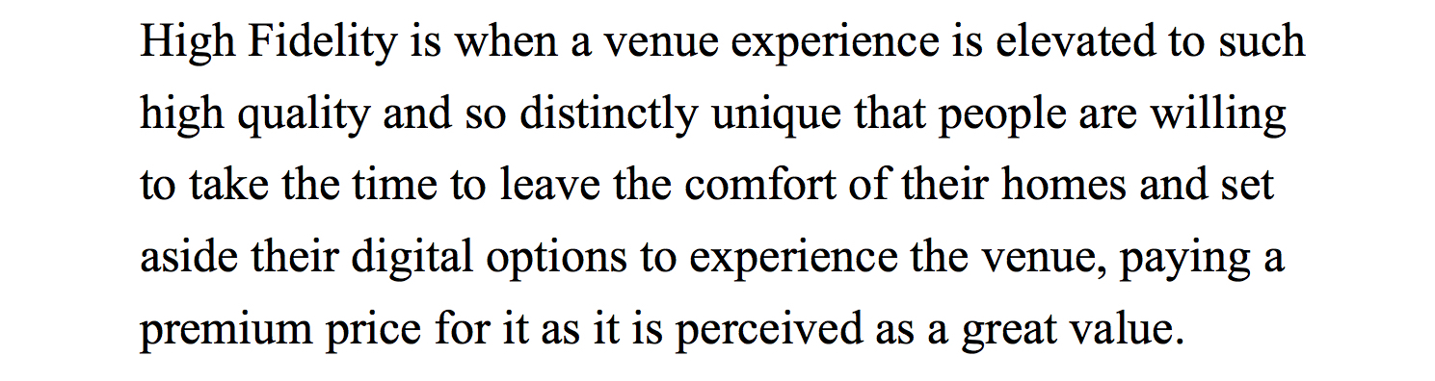For the Showcase to obtain its goal as a ‘Destination’ requires the adoption of the principle of ‘High Fidelity.’

Hence; High Fidelity experiences are inverse to convenient experiences. High Fidelity is synonymous with, high quality, luxury experiences. Convenient ones are cheaper and readily available.
For example:
Going to the sports center for a concert and light show is a high fidelity experience. The live performing artists with their energy is unrivaled, conversely the same song on mp3 is of lower value but free to download, hence convenient.
In today’s entertainment centers, high fidelity is measured in two facets;
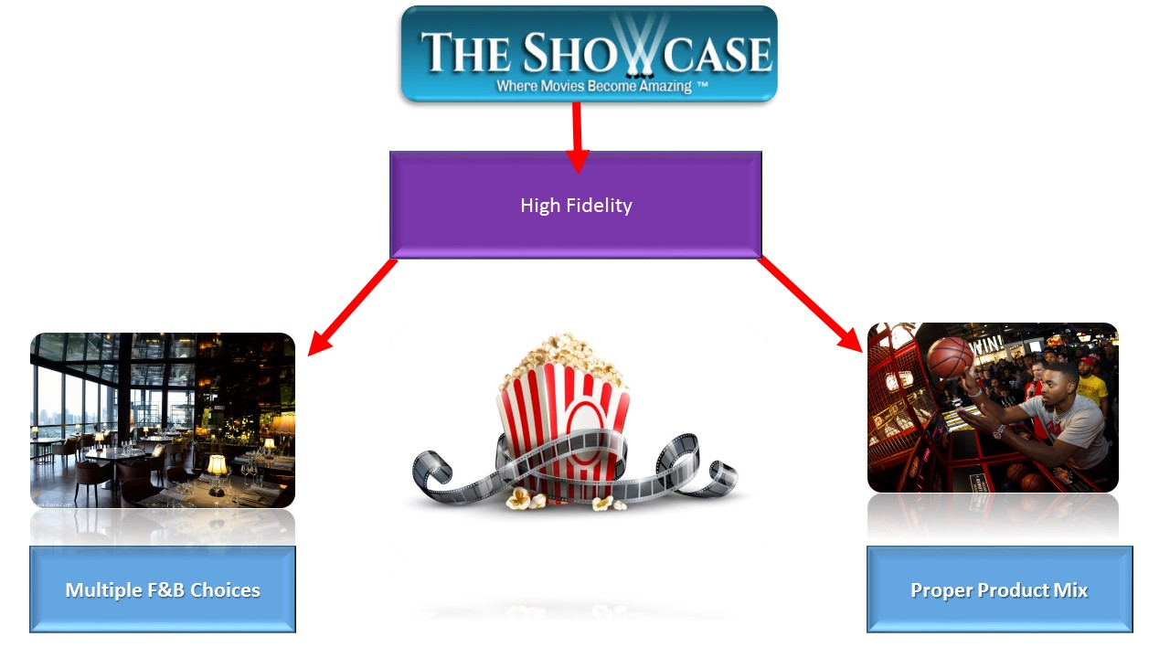

I. Food and Beverage
Understanding the need for quality food and beverage services in entertainment centers is important. Hence in the philosophy of High Fidelity, the concept of ‘Eater-tainment’ has been the most successful approach globally. Moving away from simple concessions and giving the patron a choice has yielded amazing results.
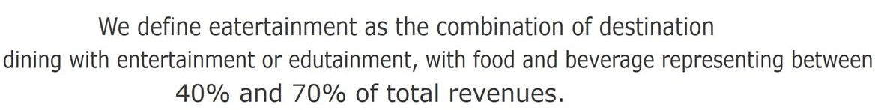First; what is Eater-tainment? Entertainment and Leisure industry consultants, White Hutchinson, coined the phrase in the mid-2000s to reflect a growing trend.
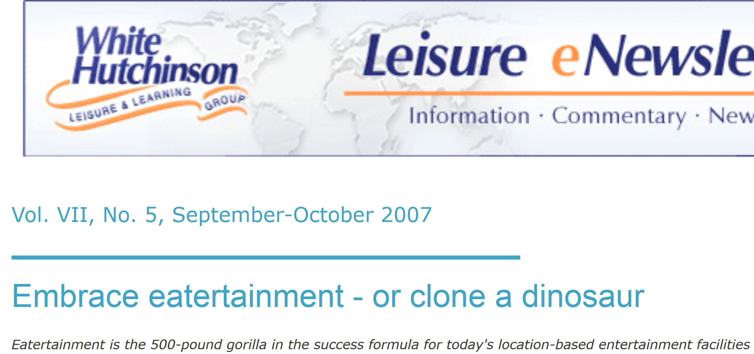
Globally the Eater-tainment formula has blossomed.
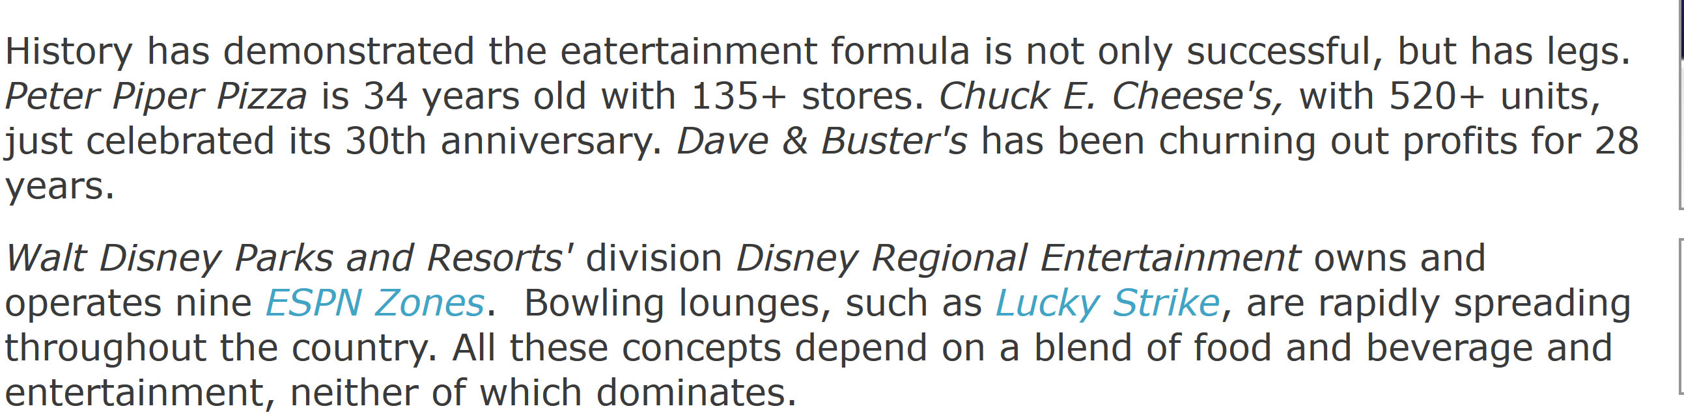
To put this trend in local perspective, one need only look to the Department of Statistics.

For the statistical years 2009-2014, Bahamians annually spent more on dining out and entertainment than education and groceries combined.
Over $400 million in dining out and entertainment

Only in recent years have the cinema industry acknowledged the phenomenon of Eater-tainment.
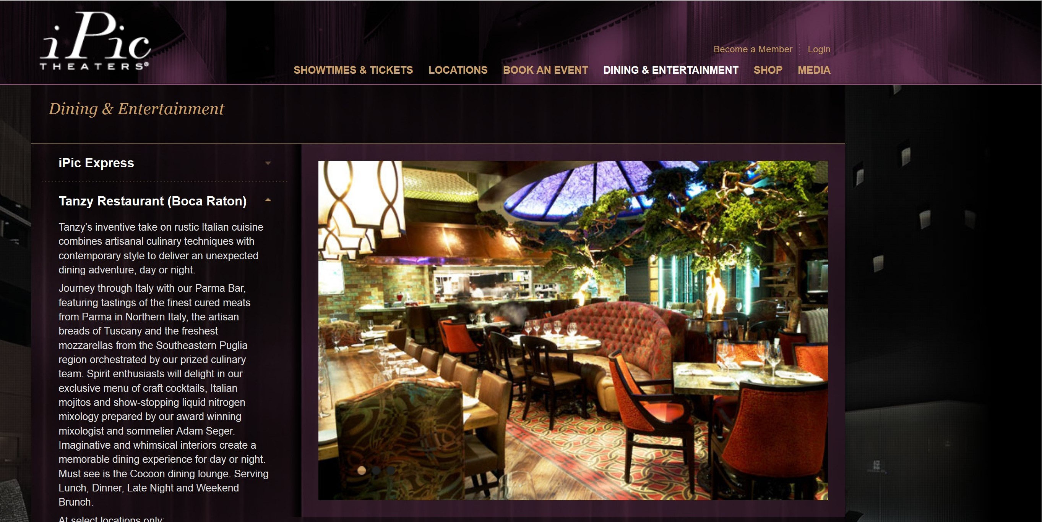

Once a company understands the value of a ‘High Fidelity’ approach, the public is there for the taking.
Case Study: AMC Cinemas adopts the ‘High Fidelity’ Principle
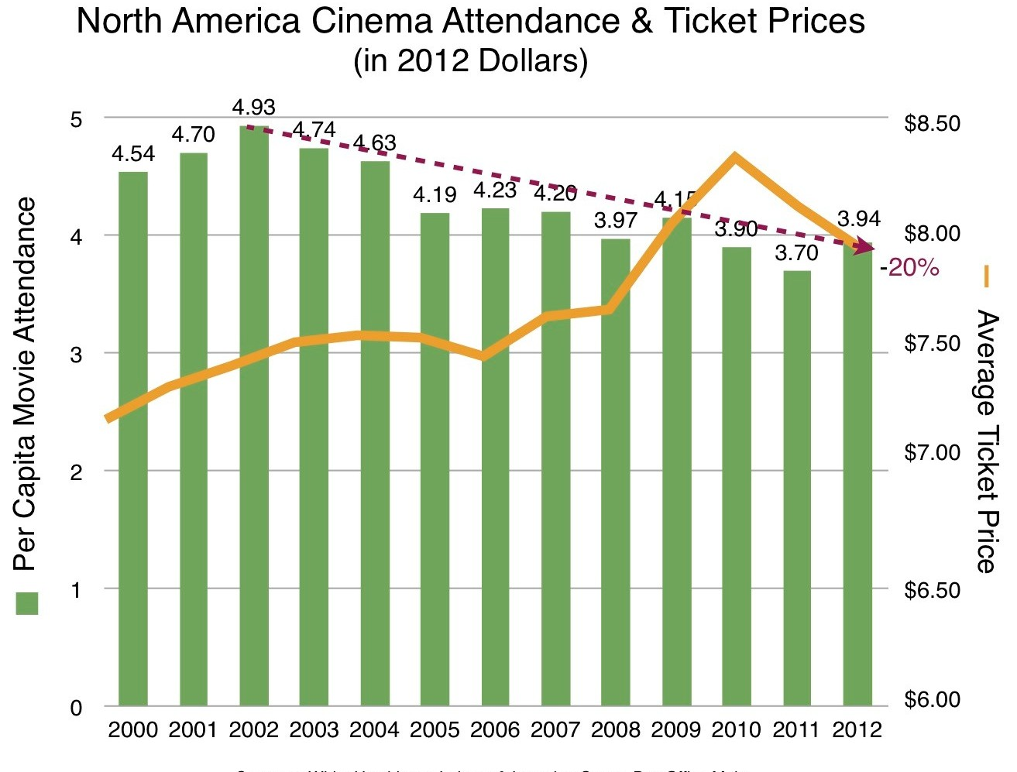North American movie attendance dipped in 2012

AMC, the nations’ second largest movie chain adopted the ‘High Fidelity’ strategy to overcome digital convenience at home. How?
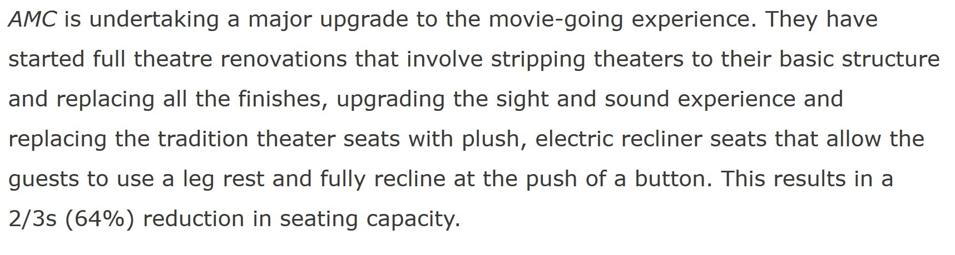Better Infrastructure

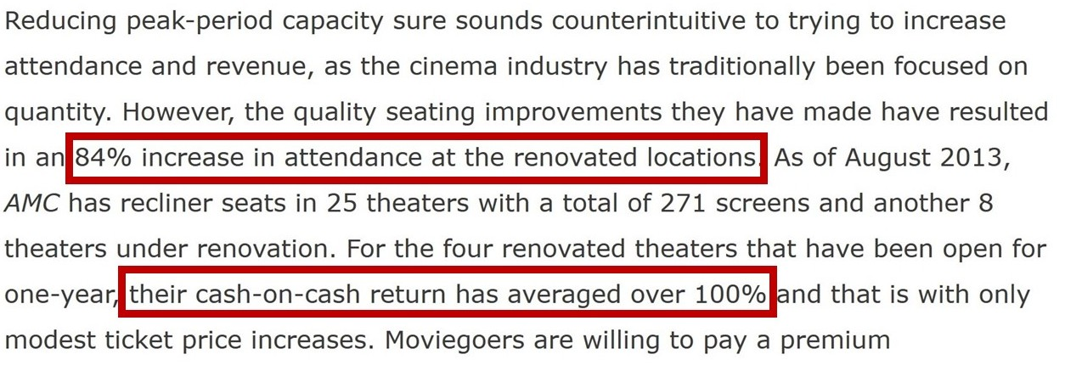Results:

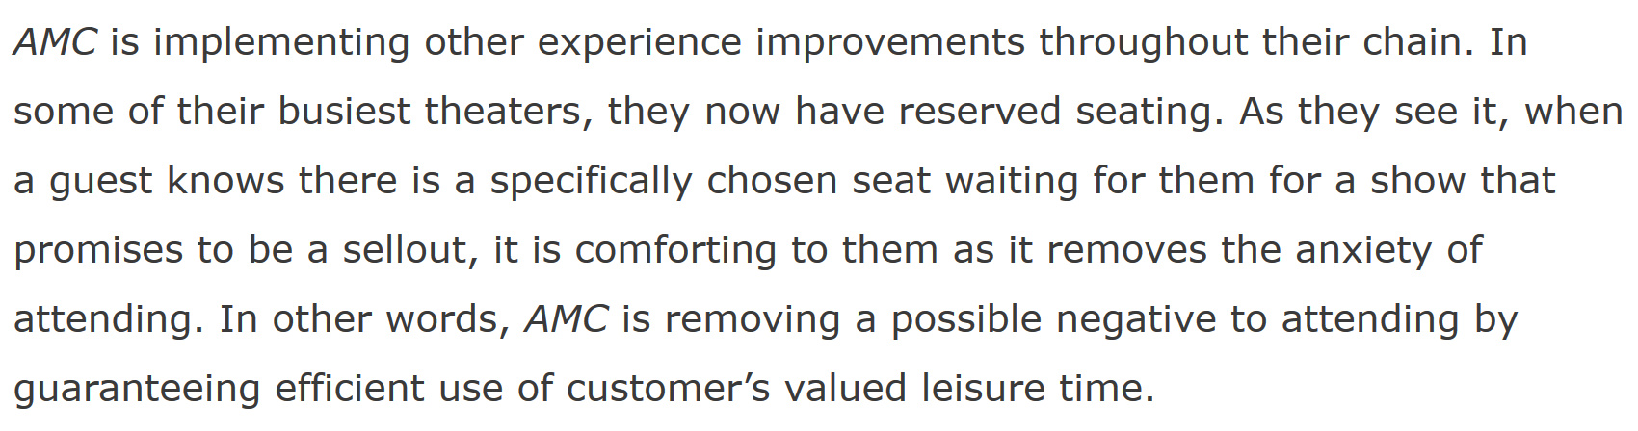Reserve seating

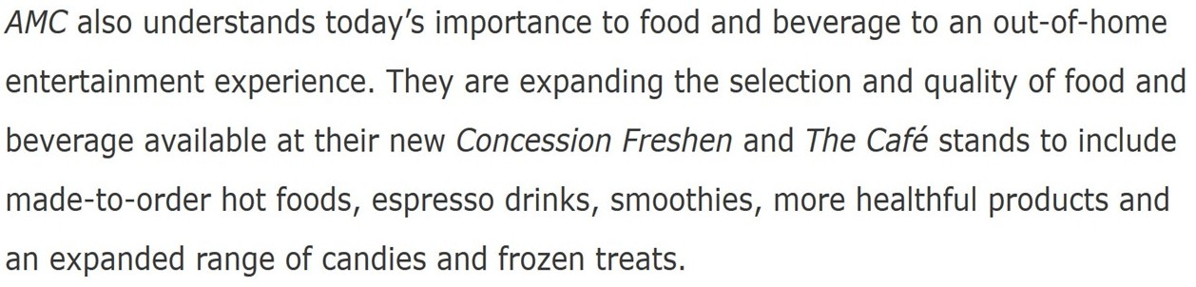Adoption of the Eater-tainment concept:

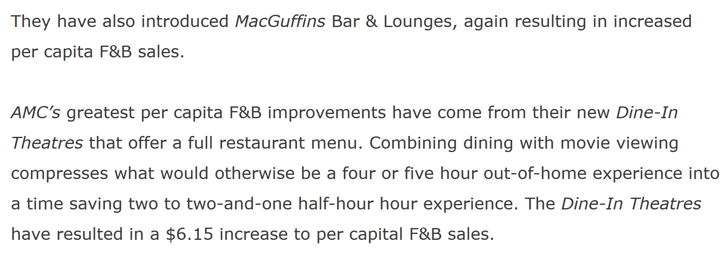Results:

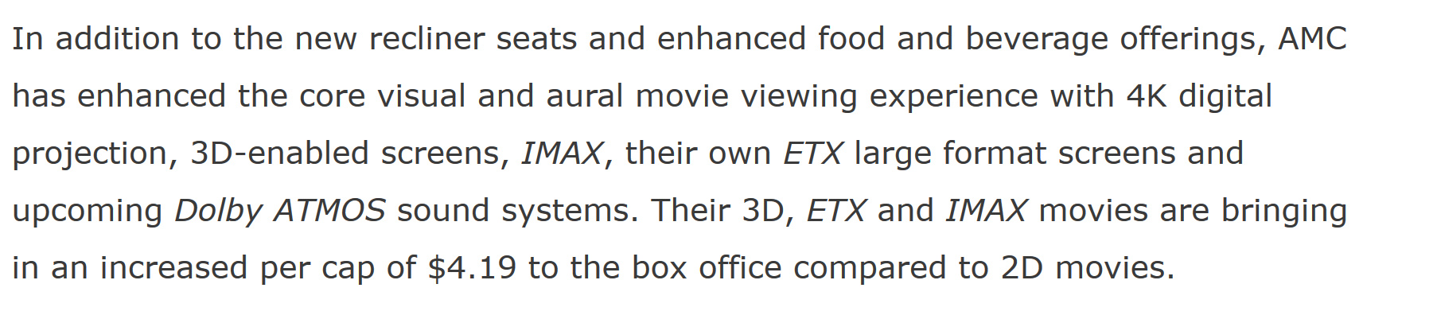Better Technology:
Hypothesis:
Eater-Tainment is an essential component of any Family Entertainment Complex. It’s also important to notice how closely the Showcase Business Model mirrors AMCs.
- From reserve seating to in-theater dining
- From eater-tainment to IMAX
High Fidelity is the only way to combat the convenience experience at home. An expansive Food and Beverage strategy is one of the keys to executing the same.

II. Secondary Attractions
The second component of High Fidelity for an FEC is the proper product mix. The state of the art cinemas are the main draw; however the secondary attractions is where the Showcase business model truly shines. Pursuant to the goal of becoming a destination, Showcase with IMAX will present a new concept to the Bahamas:
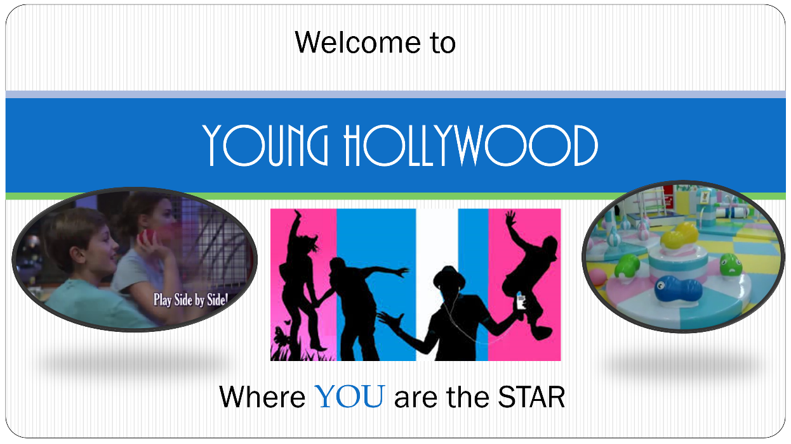
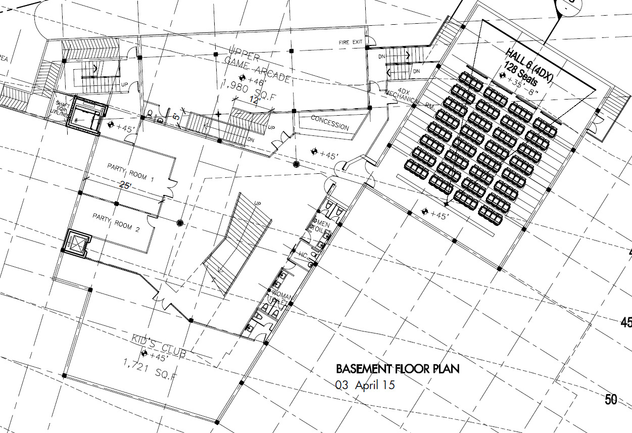
Situated on the lower level of the facility, Young Hollywood will cater to the younger demographic.
Arcade
Party Rooms
4DX
Welcome to Young Hollywood
Kids’ Soft-play Area
Before going over the strategy for the lower level, it is imperative to understand why this demographic group was chosen as the emphasis of the secondary product mix.
The two underlying reasons are based on:
- Global Industry demographic data of the main attraction ( the cinemas)
- Local Demographics data
1. Global Perspective:
Understanding the high dependency of Cinema on young patrons is demonstrated in the following:
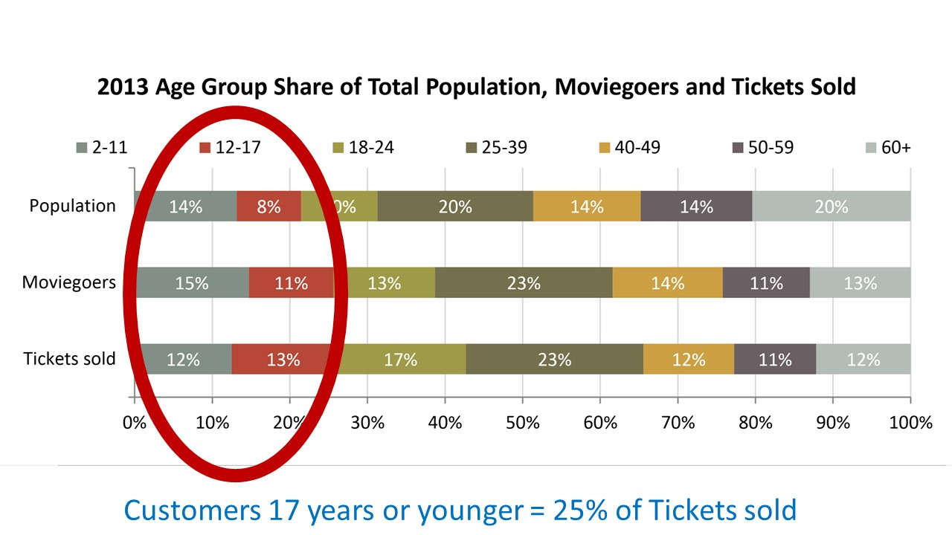
Courtesy of the Motion Picture Association of America
Kids are a very important demographic of a Cinema-based FEC. Therefore, whatever secondary product mix conceived must cater to that target group. These auxiliary attractions remove frustrations associated with sold-out movie times or not having a kid’s movie to show.
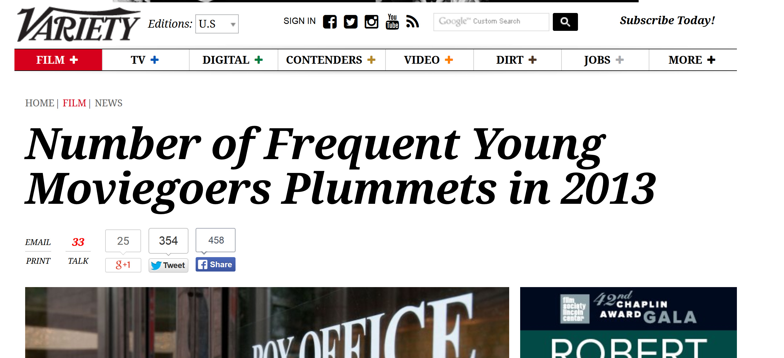2013 was a prime example of this concept:

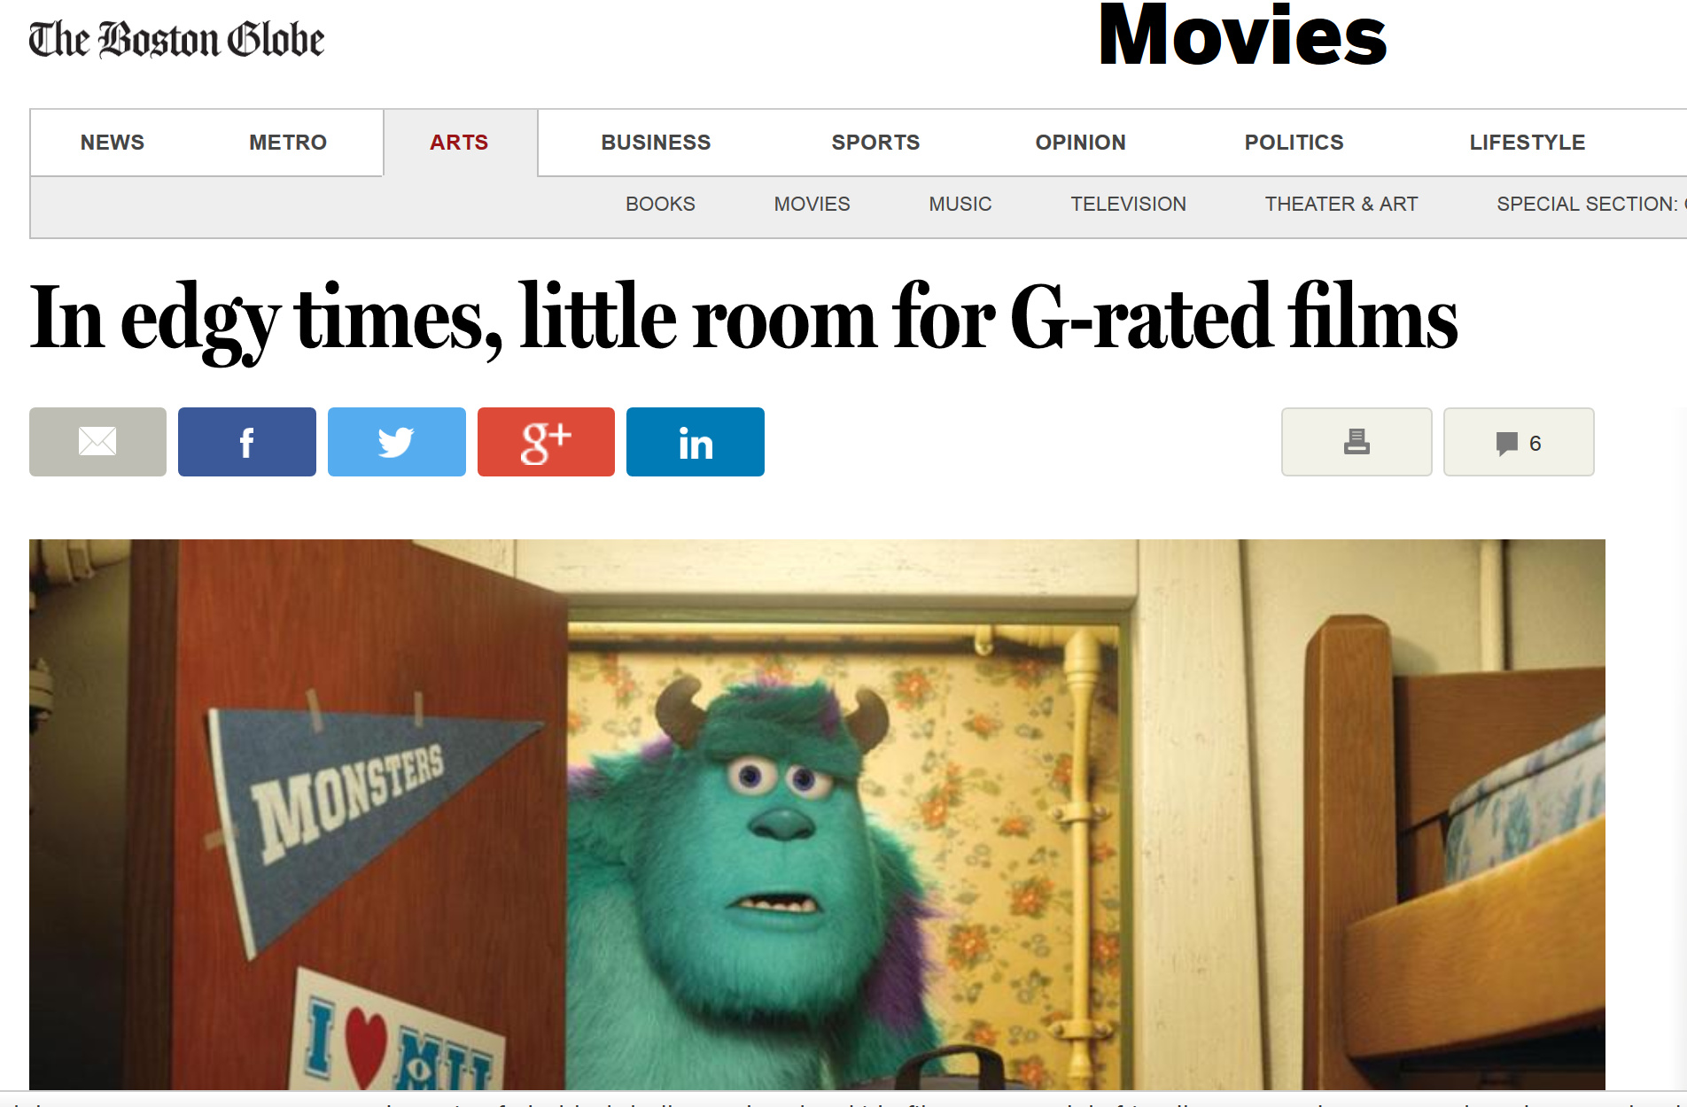What was the reason for the major drop?
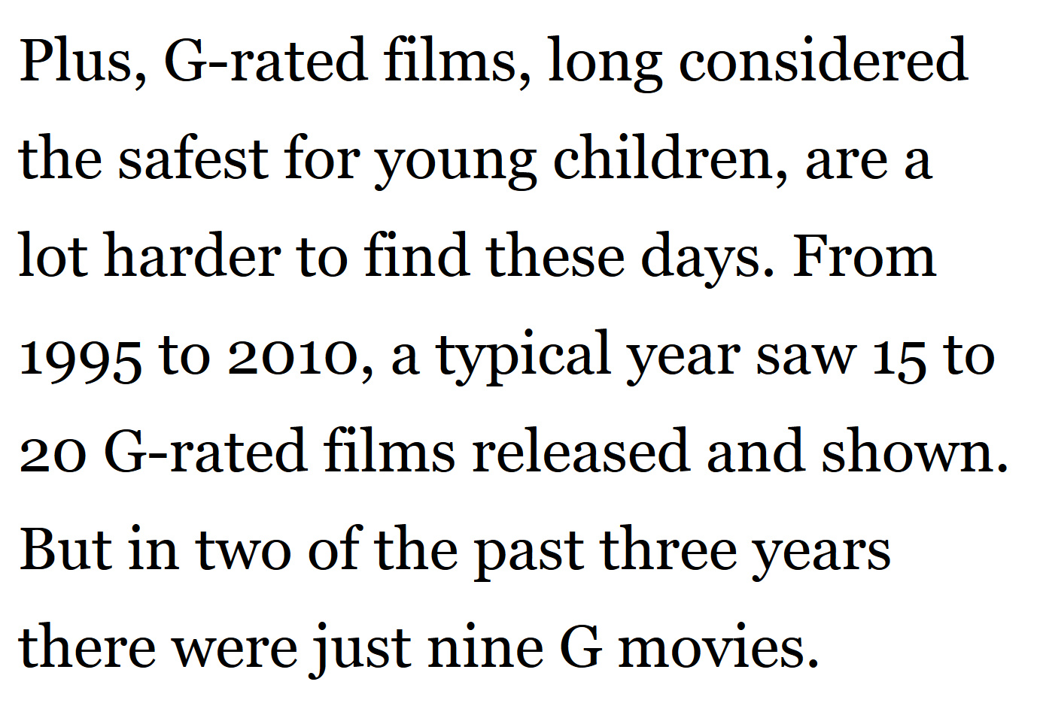There are fewer movies in that category to show.
Without products, the kids market is lost. During these periods single attraction cinemas suffer greatly.
Cineplex of Canada understood this premise decades ago. Unlike their US comrades, they have invested heavily in secondary attractions like arcades and party rooms. Hence 2013 -2014 when other cinemas were losing the younger crowd, Cineplex’s XCAPE arcade brand amused this demographic.
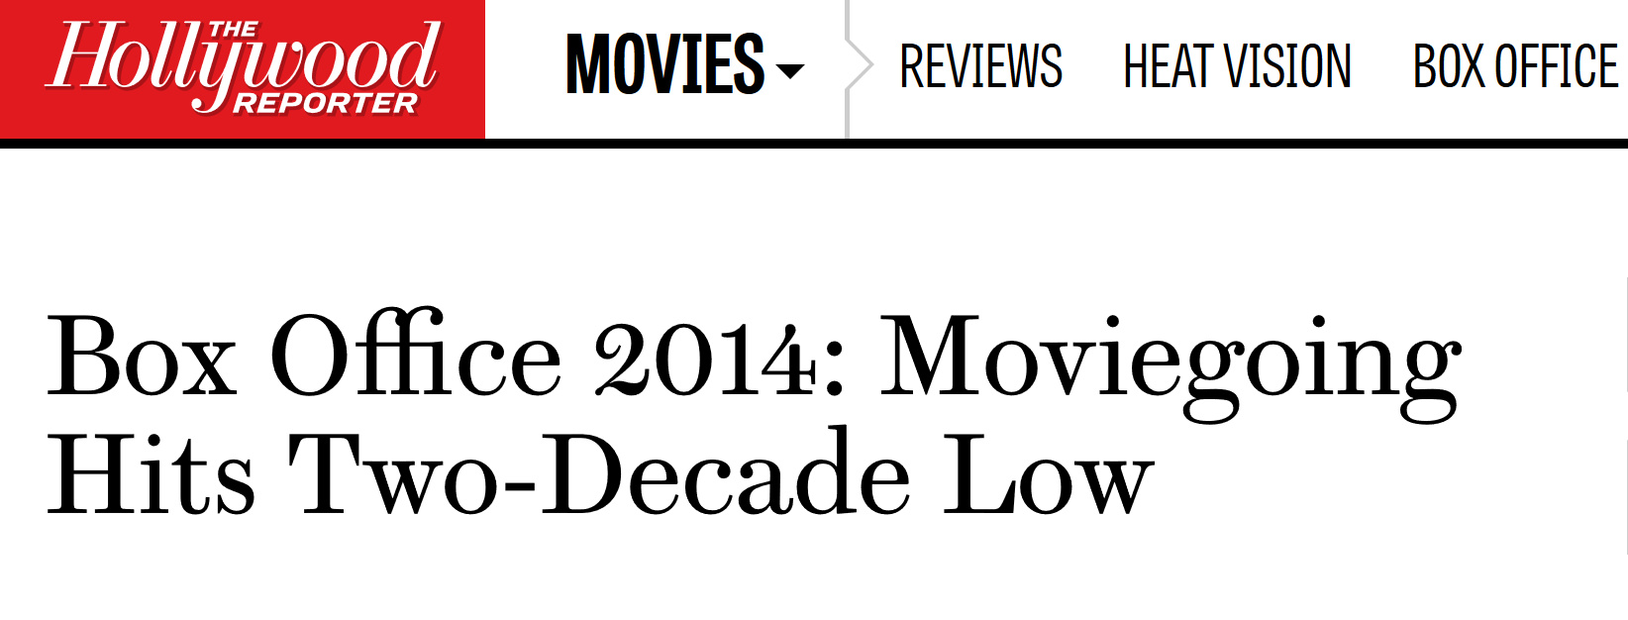For the US theater owners 2014 was a forgettable year.

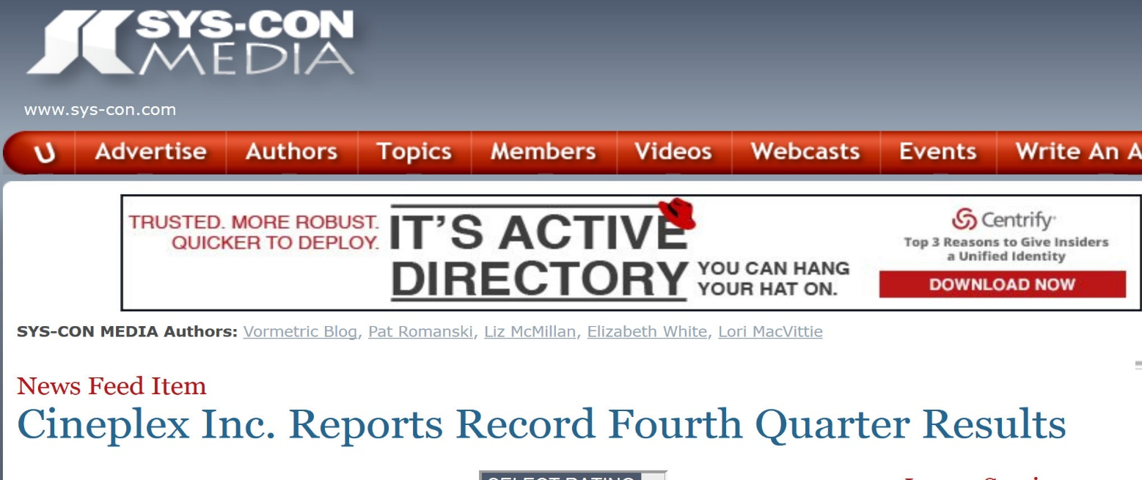
For Cineplex and its Xscape Arcade brand it was a banner time

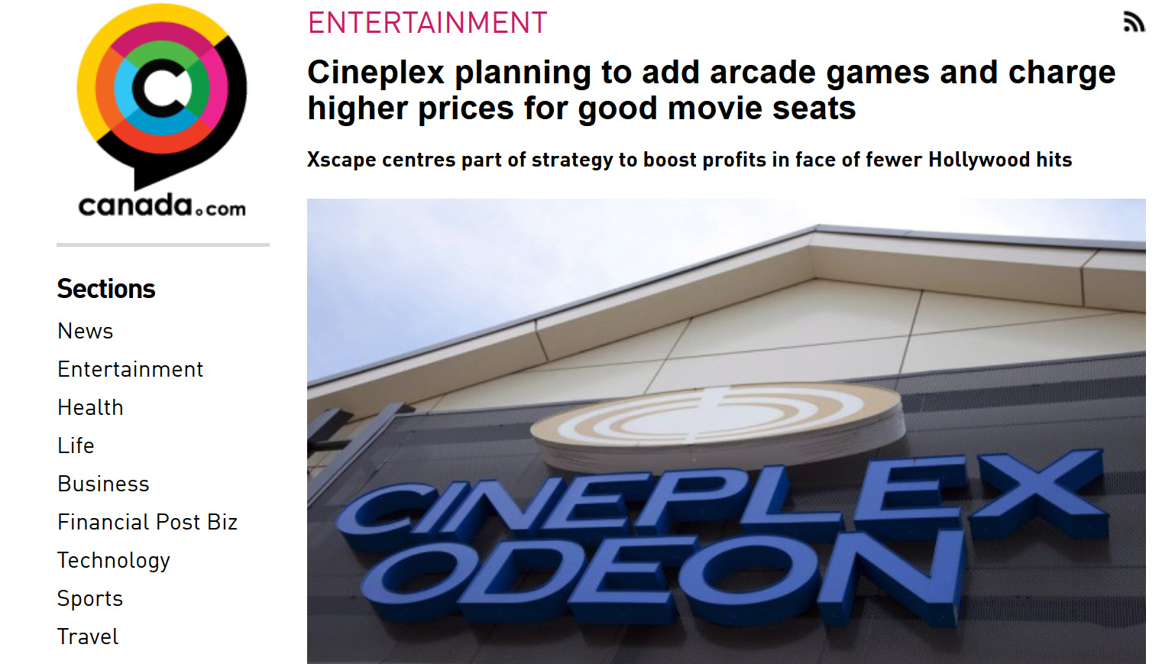
Emphasizing this point is Cineplex’s changing business model:

This corroborates the addition of the arcade as part of the ‘Young Hollywood’ concept. The goal of becoming a destination spans to all age ranges. Capturing the mind of a child builds loyalty for years to come.

2. Local Demographic consideration on the secondary product mix
For Theater- based FECs, the correct product mix drives viability. The goal of the secondary product mix is to complement weaknesses in the main attraction’s portfolio. Understanding the local population makeup is essential to this. Consider the following:
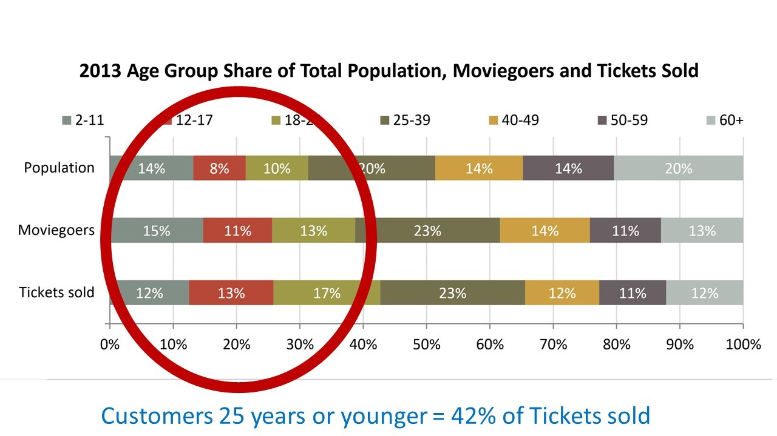
Previous analysis of the main attraction’s demographic only 17 years and under crowd. For the Bahamas it is more relevant to look at ‘25 years or younger’.

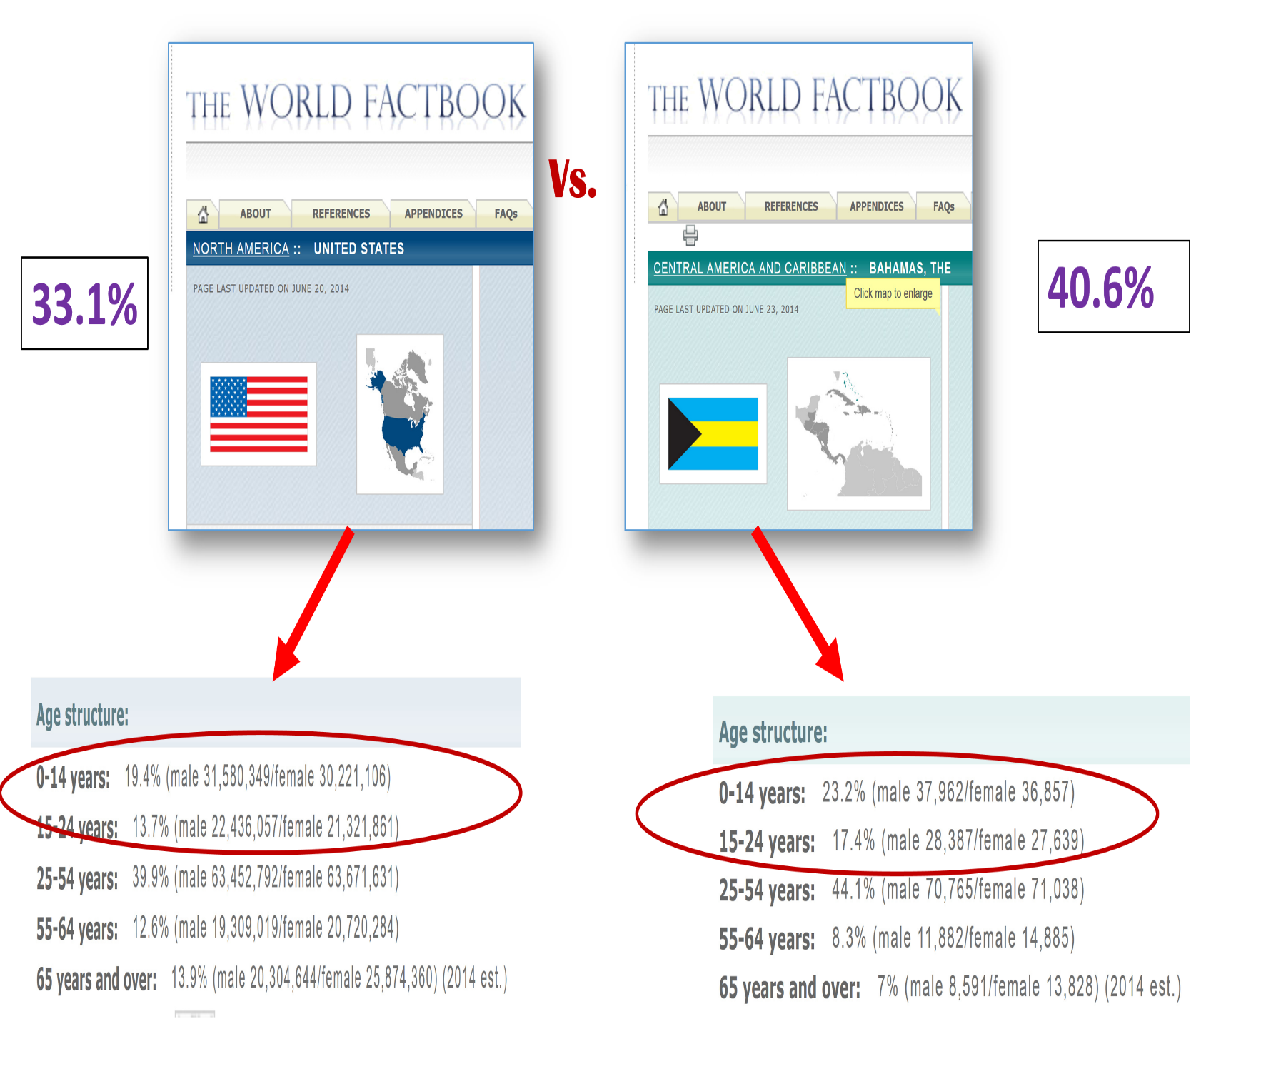
Why is this important in the Bahamas? An amazing 40 % of the country is below the age of 25years. In comparison to only 33% in the U.S.

This means that having age appropriate content is even more important. With more than 23% of the population under the age of 14 and an average age of first birth amongst Bahamian women at 26, the population is geared towards child based entertainment.
Young Hollywood’s Operational Strategy
An integral part of any entertainment facility that caters to kids is the party scene. This segment of the business can yield more than 30% of total revenue. Even though each portion of the secondary product mix is an independent entity, for the sake of expediency each will be treated as an amenity for parties.

Kids Party Strategy
Current State of Industry
The party industry in the Bahamas is divided into the following sectors:
A. Party Equipment Providers
B. Restaurant and fast food chain with and without dedicated play areas
C. Hotel with and without dedicated play areas
D. Family Entertainment Centers
Most parents want to avoid the headache of the after-party mess. Party venues are a way to fulfil their own childhood party dreams without the disorder.

Competition Analysis
The economy has made the fight to host parties very fierce. However, numerous obstacles stand in the way of these companies. A look at each venue reveals these issues:

B. Restaurants/Fast Food Chains with and without dedicated play area
- Problem (1): Very rarely do these companies have dedicated, trained staff specifically oriented to host parties for an hour or two.
- Problem (2): Most of these venues have little to no play areas dedicated for kids. If they do have a small area it’s usually for one age specific range. This thereby limits their potential.
C. Hotels with/without dedicated play areas.
- Problem 1: Venue pricing can escalate very quickly.
- Problem 2: Food and beverage are usually more expensive than fast food options
- Problem 3: Unfamiliar environment for families and their kids.
D. Family Entertainment Centers (F.E.C.) e.g. Mario’s and Mr. Pretzel
F.E.Cs are perfectly positioned to dominate the party market. The problems described earlier cannot be attributed to the same.
- They have dedicated staff
- They have reasonably priced food and beverage
- They have cheaper rental spaces

Differentiation from the Competition
F.E.Cs have the potential to dominate the party scene in the Bahamas. Separation between F.E.Cs is determined by two factors:
1. Basic Party packages
2. Amenities

1. The Basic Package
It’s of utmost importance to understand the necessity of a quality ‘Basic Package’ for parties.
It is the single biggest determining factor when parents are looking for a party venue. The proverbial ‘minimum’ price is what draws parents in:
- If the basic price is too high, the other amenities won’t matter.
- If Basic Package does not cover the minimum requirements by the target audience, then the perceived value is lost.
Currently in the market; it ranges from (Mario’s $250) to (Mr. Pretzel $350)

For between $250 and $350 (minimum of 8 people) customers get:
- A drink
- A slice of pizza/pretzel
- Seating for 8
- 1hr time slot
- $10 of bowling/tickets
This is considered value in the market. Young Hollywood will come in at a base price of $250 and match the standard package. However, this is where matching ends. With state of the art HD TV in both party rooms and cinema specific theming, all comparisons cease.

Introductory Phase
- Allow online/ or facility booking of parties yet require hostess assignment for confirmation purposes
- Empower hostess to upsell the other amenities of the facility.

2. Amenities
The maximum viability of a facility’s party revenue is dictated by the amenities it possesses.
In today’s economic environment, value has taken on new meaning. Allowing parents to fulfill their dreams for their children, yet within their budget, is paramount. Providing value requires a level of customization and flexibility which must be reflected in the facility’s amenities.
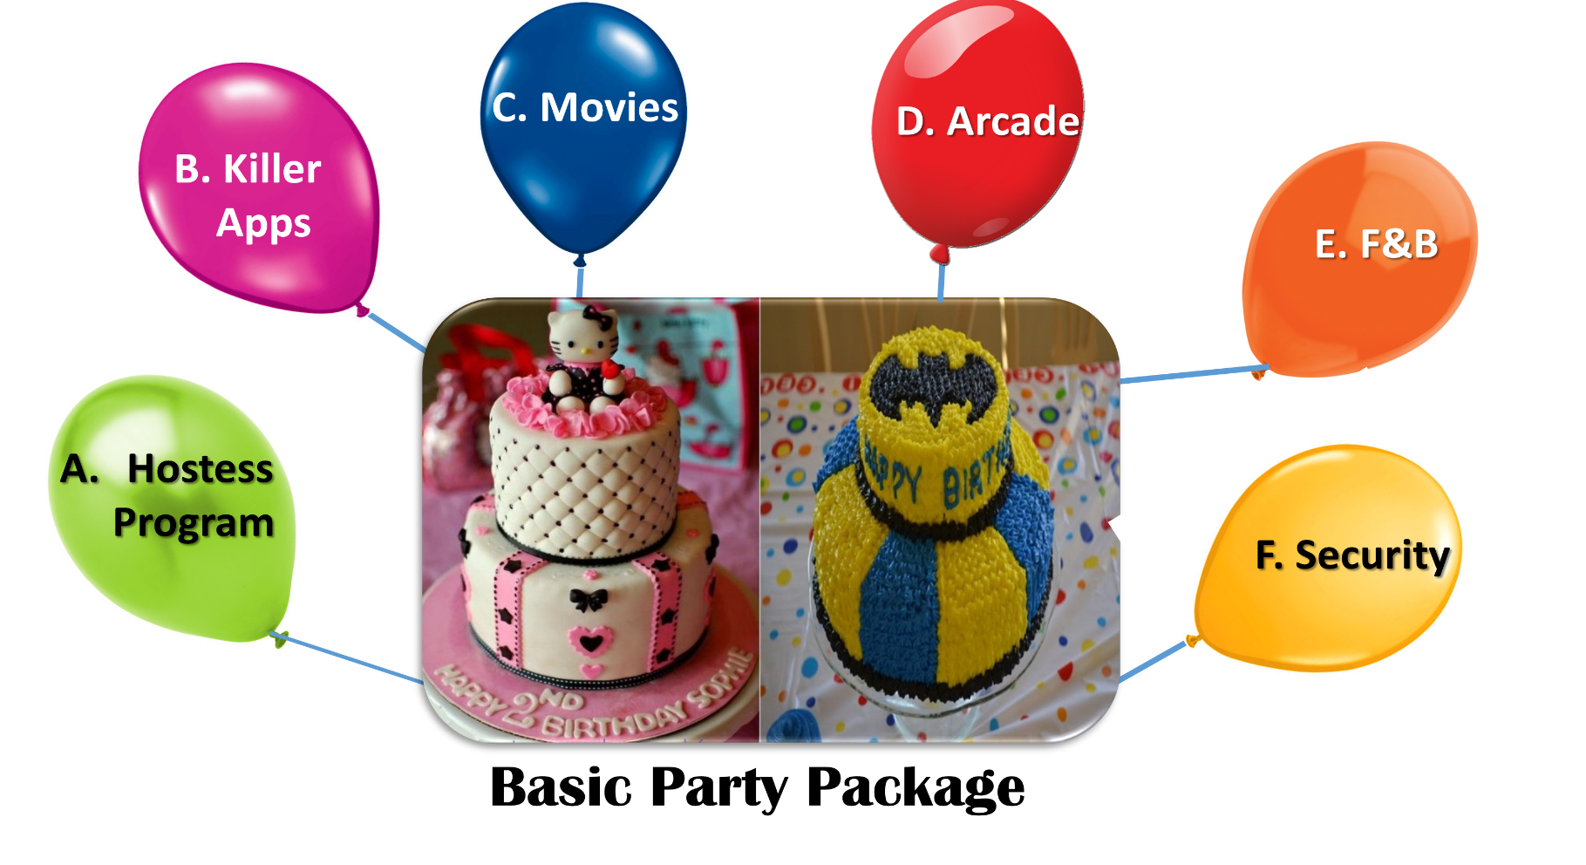
Amenities, which will be added to the basic party package, are as follows:

- Hostess Program
The facility’s ‘Ambassadors of Play’ will be the focal point of our customer experience. The hostess sets the tone for all other options that can be provided, hence she is the most indispensable amenity. These Ambassadors have a three pronged approach to client relations:
    - Before Party
    - Critical Mass
    - After party Activities

Before Party Activities: Customer Interaction
- Be the Parents Advocate
Make sure they understand what the facility offers. Customizability is paramount. Let them build their own package and they will take ownership
- Setting Expectations:
Listening to the parents and setting boundaries is important. Differentiating between what they want and what they can afford determines client satisfaction rates
- Know the Personality of the Client
Some parents want walk-in parties with only activities. Others want the structure of a party room and privacy where the hostess is to be hands on.
- Recognize what activities are needed :
Its very age and group size dependent

Critical Mass: It’s Party Time
Arrange to meet the arriving group at the concierge desk in the lobby. Walk them down VIP Style to the party rooms.
During the party the hostess has three targets;
- The B-day child
- The party attendees
- The parents

B-day kid:
Making the day special is key. Identification is the trick
Whether it’s a sticker with their name or hats with their picture on it, give the celebrant something personal that also contains the facility’s name on it. Besides advertising, this also builds brand loyalty.

Party attendees:
Always Identify ALL parents in the room. If there are 12 parents in the room that’s 11 more potential customers.
They all get a special gift:
(1) A complimentary discount card at next party.
(2) A free popcorn with purchase of large drink.
It’s all about making them feel wanted.
.
3. Parents:
Be the parent’s right hand thereby becoming an extension of them. If the proper leg work is done before the party starts, the parents will be prepared properly to enjoy the experience.
Now is the time to WOW ‘the parent’ in front of the other parents. Always give something ‘free’ that was not in the package. Bring free ice-cream coupons for the kids and free coffee for all parents.
Of course give the parents complimentary movie tickets.
It’s all about providing value. To this end the Hostess must continue to gauge the flow of the party to determine the level of interactivity needed. Whether its initiating games or making sure the event stays on schedule, the Hostess is vital to the flow of the party.

After Party Follow-Up: Start what you finish
1. Call the customer up and let them know that you appreciated their visit and to show your gratitude give a 10% discount for future parties that will remain on their account for 6 months.
2. Tell them about the options they didn’t try and offer a further discount on those items.
3. Let them know that there will be a referral bonus that can be used anywhere in the facility.
4. Finally customers will be asked to rate their Hostess and the overall experience to receive a portion of their deposit back.

The Hostess should make note of all complaints or unsatisfied customers. All bad experiences should be reported to the supervisors.

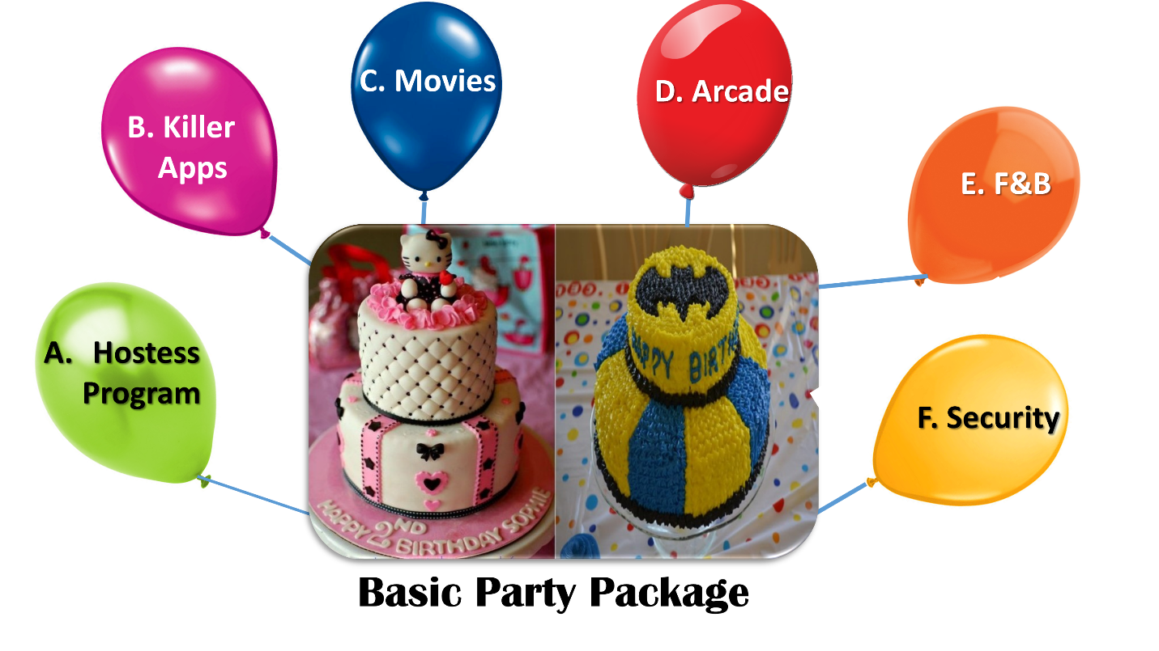
B. Killer Apps.
The main target group that the party area will cater to is between the age ranges of 4-15years.
Killer Apps refer to an amenity that sets apart the party experience from anything currently in the market. Even if the competition duplicate one of the following; it is the sum of its parts that makes for a compelling and enjoyable party environment.
Killer Apps are components that focus on the entertainment needs of each group without removing the focus off the kids. Great care has been taken to place these products strategically to avoid conflicts while maximizing profitability.
Market % | Target Group | Killer App. | Untapped Market
80% | Toddler to 7yrs | Playbox | *Expats  *Kindergarten/ Nurseries  *Single Parent
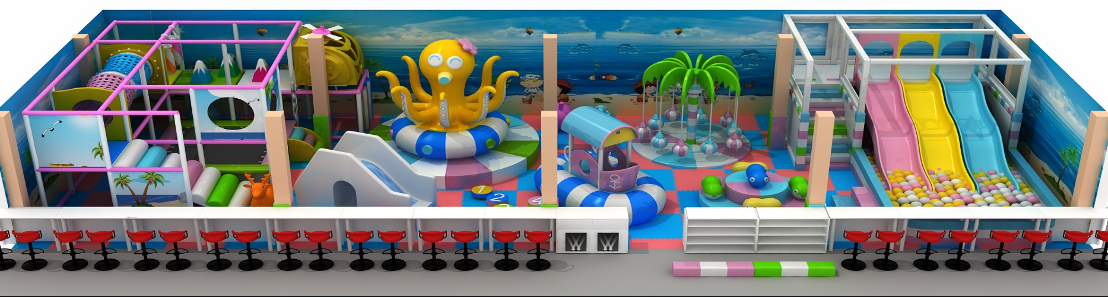
Playbox Business Model:
 | Assume the following:
 | Opening hours of 10 am to 10 pm during high season (June, July, August, December)
 | Highest attendance 3pm to 6pm - weekdays
 | Highest attendance 4pm to 8pm - weekends
 | Charge $5 regular fee for 30 minutes intervals | $ 5.00
 | Charge $4 weekdays before 3pm | $ 4.00
 | Charge $3.50 on Mondays whole day (special) | $ 3.50
With over 1000sq. ft. of play area, Playbox present a unique revenue opportunity. The Hostess can upsell the amenity for parties as it is the only one of its kind in the Bahamas, limited up to 7yrs, parents can watch their kids in a comfortable and secure environment. With a price tag of under $60,000 the ROI is under six months.

Market % | Target Group | Killer App. | Untapped Market
10% | 8-17yrs | Atomic Rush | Youth Group
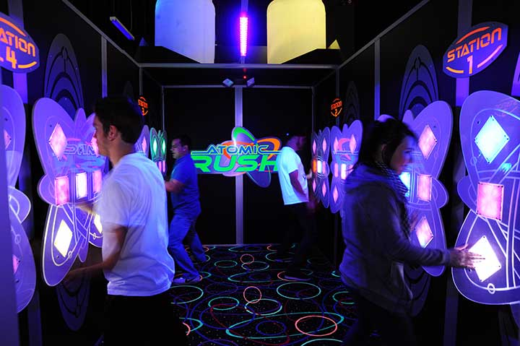
Atomic Rush

Think you have cat-like reflexes? Prove it in ATOMIC RUSH. Here’s how it works. Choose one of 4 colors to play independently or against as many as three friends. The object is to tap as many of your colored lights within the arena in a 60-second time period as possible. With several modes of play, including scramble that requires you to run around the entire arena in search of your colored light, you are bound to feel the RUSH!
Atomic Rush is the perfect upsell product for older kids that want to compete against each other. With ROI 4 times the average arcade machine, Atomic Rush will be a party sensation.

Market % | Target Group | Killer Apps. | Untapped Market
10% | Family | Fun House | Parents at party that sit there bored (Fathers)

Fun House
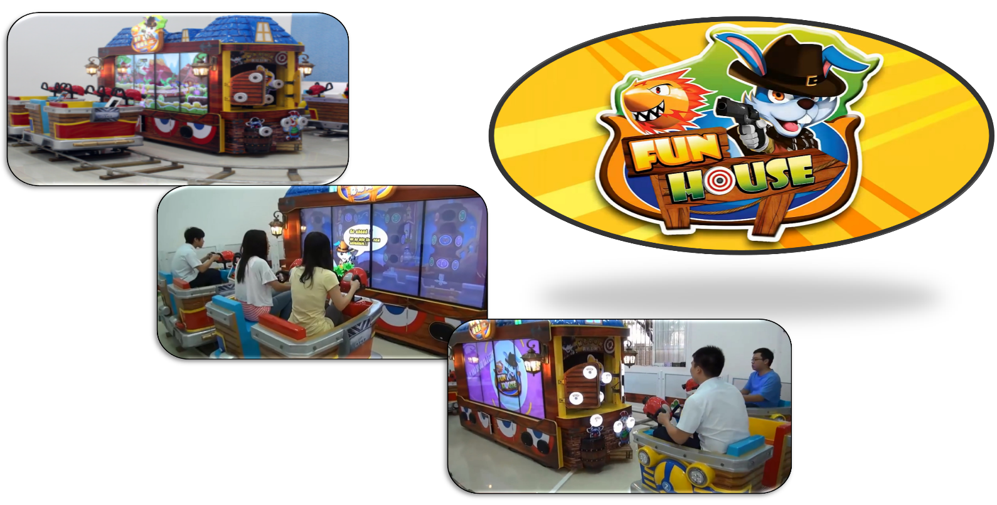

Imagine a ride for a family of 8 that rewards the family with tickets and prizes. Imagine no more; this interactive experience will bring families back time after time. With over 14 different games to compete against each other or with each, the possibilities are endless.

C. Movie Component

The Movie component of the Party Package is a very robust program.
- Hollywood Content
This component’s availability is based on numerous factors:
- Age appropriate content
- Movie release dates
- Not shown until after 1pm daily
Because of these features movie titles must be booked the Tuesday of the week preceding the party.
- IMAX Educational
This component is very interesting, in that parties can be themed for these films. However these parties must be between the hours of 9am-12pm
- 4DX Component
4DX is an exciting format. Most films last between 9-11mins hence parents can enjoy the experience and the other money makers (Arcade/Playbox) can still be fully explored.
Limitation:
- Only between the hours of 9am-12pm on the weekends
- By request only during week days with an average party size of 20 and above.

- Alternative Content
Alternative content refers to an assortment of programs that can range from Russian of Ballads to the Barbie pre-DVD release event.
Limitation:
- Subject to availability
- Subject to age appropriate content
D. Arcade
Note: Arcade covered extensively in Arcade Report.
From a party perspective, arcade is a vital component/activity for adding value.
Arcades take care of the individual component of the party. Some party goers want to compete against each other. Other members want to win prizes. No matter whether it’s individually or collectively, the arcade is stocked to meet their needs.
E. Food and Beverage
Whether it’s the basic pizza and soda or a more complete meal, the facility is versatile. Having a full restaurant on the property is important for ‘made to order’ events.
Whatever the needs of the guests the Hostess has the flexibility and tools to serve the customer.
F. Guardian and Chronosplay
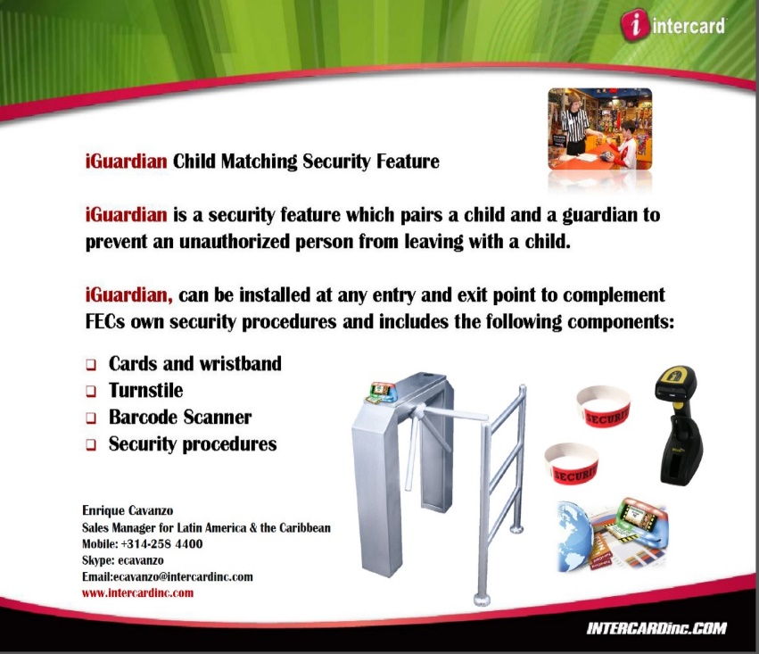
These technologies are the gatekeepers for the arcade as well as the Playbox area.
All of these amenities ae fun and add value to the customer experience. However, safety and security is the number one concern for parents.
Guest must feel that they can trust that their environment is secure. Besides cameras and security personnel, parents also want to keep track of their offspring. To this end, Guardian and Chronosplay are the gatekeeper technologies that safeguard the children on the property.
If a parent wants to leave a child/children in the arcade playing games while they enjoy a movie, iGuardian can handle that. iGuardian is a software/hardware solution that pairs children with parents. This provides security, convenience and value.
Security
The parent(s) and child/children get a wrist band. This serves 2 functions:
1. Only the parent can scan the child/children out.
2. The child/children cannot leave the designated area alone. In the case of the arcade, turnstiles prevent little precious ones from escaping into the rest of the facility.
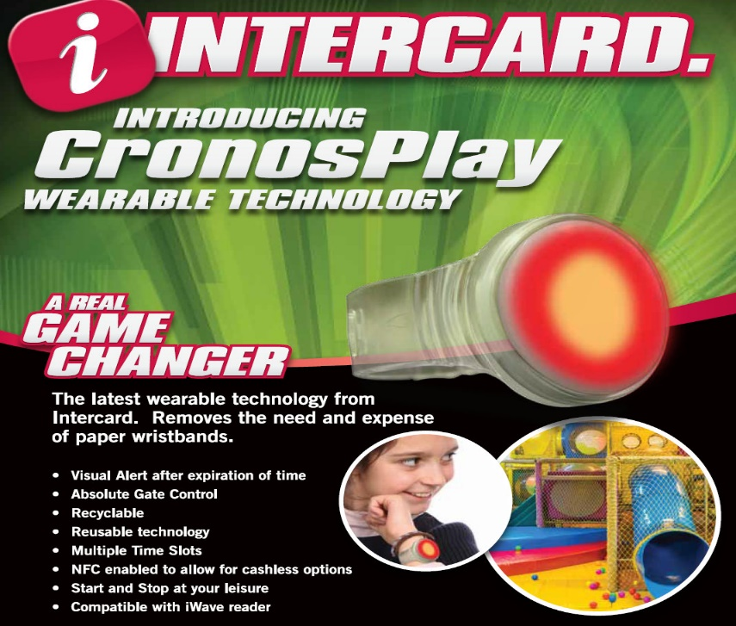
Convenience
Chronosplay is a convenient way of making sure kids can be monitored by parents while in their movie or at a restaurant without leaving their activity.
Value
Children can also perform cashless transaction when the allotted funds run out at preset limits by parents.
Note: Additional features include
Playbox time monitoring
1. Parents can preset time slots for playing privileges around their party time.
2. Parents, Attendants and Hostess can visually see when paid time is up.
This comprehensive approach to the party business model is vital to market penetration.
Summary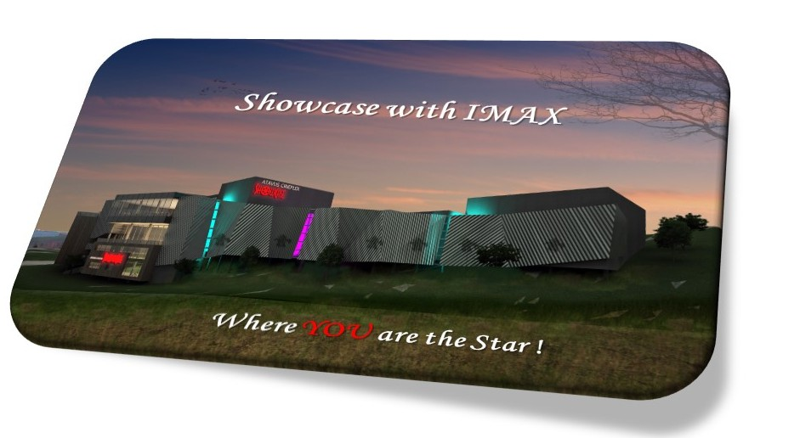Creating a ‘Destination’ is synonymous with building a dream. Whether it’s the anticipation of a child for PLAYBOX or young adults craving the 4DX experience; emotions are the currency by which destinations are built. The Showcase with IMAX, hence must be dream weavers.
High Fidelity is the foundation by which a steadfast business model is built. The same has to be nimble enough to withstand subtle market shift or industry wide downturns. A well-conceived product mix, proper F&B coupled with a customer focused approach will be paramount.

Building the experience will lead patrons to their destination: The Showcase with IMAX

